Games and Resume Website

Website for showing projects and small games I have worked on.

Camden Gugel

Portfolio Project

Spring 2025

**Table of Contents**

Short Description/Statement of Purpose 2

Application Full Description 2

Technology Stack 2

Site Pages/Page Descriptions……………………………………………2

Next Generation Features………………………………………………..3

Wireframe and Use Case Scenarios………………………………….4

Pseudocode……………………………………………………………………..4

Application Images…………………………………………………………..5

Version Control Log………………………………………………………….7

References/Credits…………………………………………………………..7

# Application Short Description: Statement of Purpose

The purpose of this assignment is to create a working and visually pleasing website to show coding projects I have worked on or am currently working on, my resume, and short games I have made in the Unity game engine. It should also include links to social medias and code examples. The website itself will be a 2d-platformer with a character that can move around, jump, and interact with boxes to open different sections.

# Application Full Description

The website “camdengugel.tech” will be hosted on GitHub as a way to compile various projects I have worked on or am currently working on, as well as things like my resume so that I have a website that I can proudly show to employers.

The website should have a welcoming page with images and links, with a separate menu that leads to other pages in which different games are hosted or projects are placed and explained. Additionally, the web page should have links to things like my LinkedIn and GitHub accounts, and ways to get in contact with me.

In terms of design, the website should be colorful and tech-inspited. I will incorporate things like colored boxes, character sprites, and varying placement of text of images to give the website a fun but professional look.

# Technology Stack

The website will be hosted, ran, and updated through GitHub with the domain name of “camdengugel.tech” through an HTML index file. Games on the website will be hosted using WebGL which is able to be downloaded directly out of Unity software.

## Site Pages

This app can be deployed as a single page app with boxes to open different info by interacting with them:

Main page with sections and movement index.html (main page)

Platformer mini game with platforms, pits, and goal platformer.html

Pages for unity games along with short descriptions snake.html (e.g.)

Site for simply showing resume resume.html

### Page Descriptions:

index.html

main character and movement

controls/instruction on bottom

boxes to jump into for about me, skills, projects, contact

header sections that pop up with info for the box touched

about me section with info and selfie

skills section with link to resume

projects section with link to design doc and snake.html

contacts with email and LinkedIn

portal that leads to platformer.html

platformer.html

main character, movements, controls

interactable platforms

pitfalls that restart level

goal that displays “you win” message and restarts

death counter for amount of deaths

return button to go back to main site

snake.html

game title (header)

Game in the middle of screen.

Short description of game, how it was made, etc.

footer (creative commons license)

resume.html

Shows resume with borders around it

## Next Generation Features

The app will be updated regularly as I work on more projects and update my resume. As I create more games, I will add them to the projects along with design documents for them if applicable.

# Wireframe and Use Case Scenarios:

# 

# Pseudocode:

**Index.html**

Header

Import fonts and stylesheet

Title

Style

Google Analytics Tag

Body

Infobox

Controls

Canvas

Script

Game logic

Section/info box placement and info and links

Character sprite and game loop

End

**Platformer.html**

Header

Title

Style

Body

Game logic

Back button

Victory message

Character sprite and game loop

End

**Resume.html**

Header

Title

Body

Resume

Border

Download button

End

**Snake.html**

Header

Title

Body

Game container

Game script

End

## Application Images

Index.html

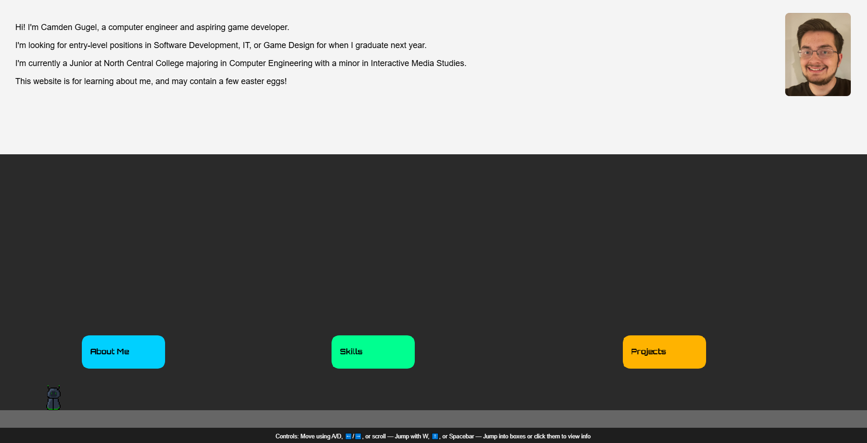 Platformer.html

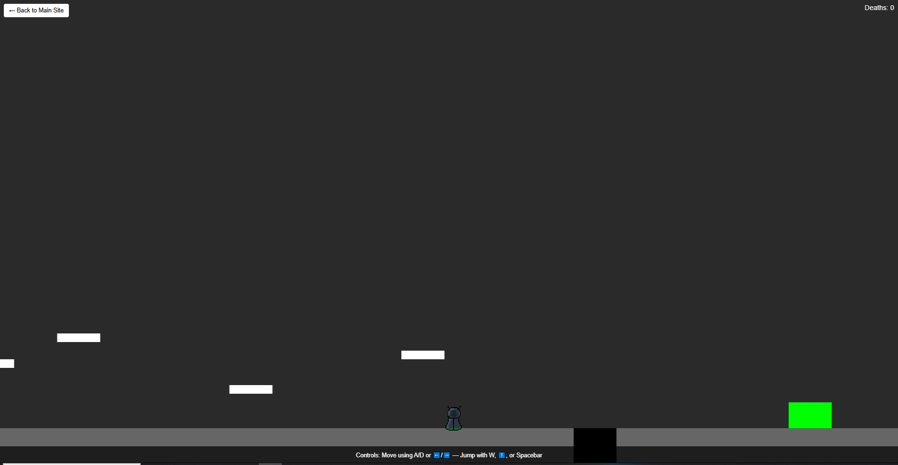

Resume.html

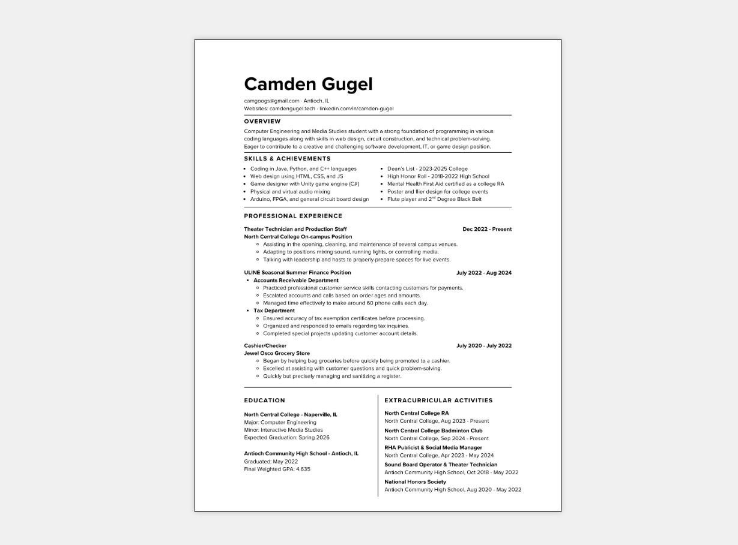

Snake.html

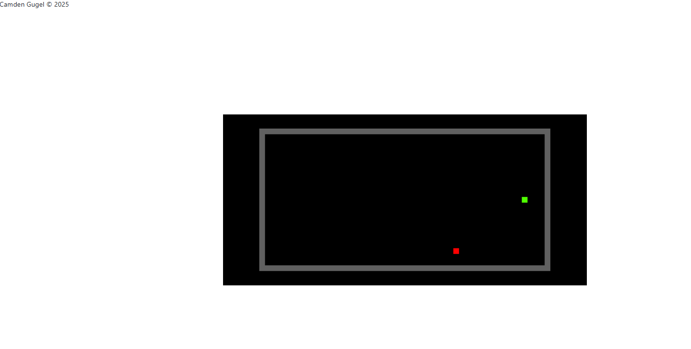

# Version Control Log:

Project Part 1: Goal Declaration and App Overview February 2, 2025

PortfolioProject1.docx

@author Camden Gugel

Project Part 2: Update and Expand Initial Description February 28, 2025

Updated short description to include links

Added site pages, NavBar integration, and page descriptions

Added Next-Gen features for updating plans for future

Added version control module at end of document

PortfolioProject2.docx

@author Camden Gugel

Project Part 3: Greenfield original website, change scope March 29, 2025

Updated to match 2-d platformer idea

Added wireframe and adjusted all sections to match new ideas

@author Camden Gugel

Project Part 4: Added pseudocode for all separate pages April 12, 2025

@author Camden Gugel

Project Part 5: Added application images and finalized doc April 29, 2025

@author Camden Gugel

# References:

Developed with help from ChatGPT and in-class help from Professor Clinton Garwood.